**HOTEL MANAGEMENT PROJECT IN C++**

**Objective:**

This new hotel management has been developed to meet all the processing requirements which are needed within the hotel industry. This system will allow the hotel reception department to manage all the records of their customers and their payment in easy manner. The person who will use this system will able to get all details on how to use the instruction in offline mode, so no need to take special training before using the system. All proper keywords has been used to define each function of this new system. To use this system, its users should have a valid password.

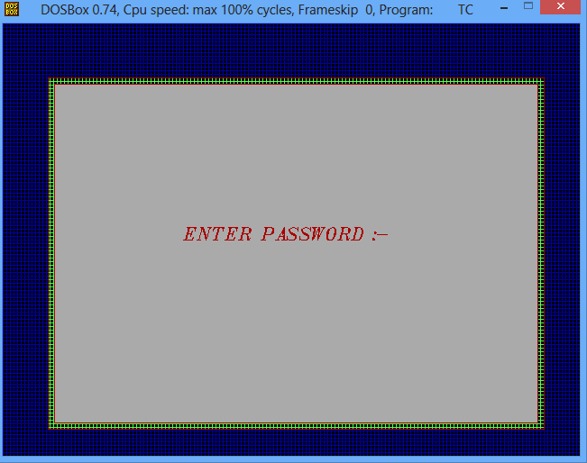

Once the correct password will be entered, verification process will be taken place at the backend side and if entered password will be correct, admin will redirected to the next section, where they will able to handle all the business activity using the computer system.

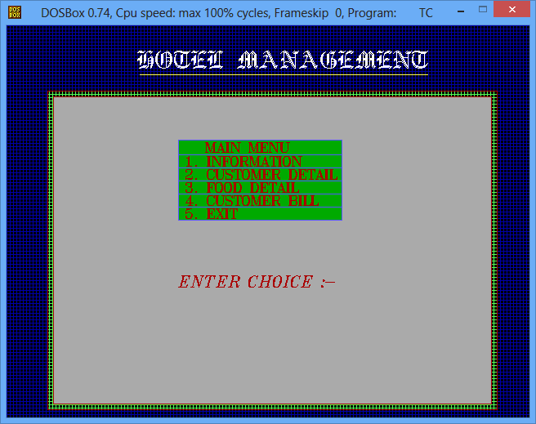

The use the system for exact operations, admin will have to enter the correct option provided under the main menu screen. To perform all the operations related to any particular customers, admin will have to use the option number 2 which is available under customer detail. If new customers arrive to their hotel and their data need to be maintained, admin can append its details to the customer’s record file.

**Existing System:**

Existing system do not much flexibility and reliability which has been provided by this new hotel management system. In the previous system all records were saved in file under text which can be easily readable by the other person if certain mistakes has been done. Even if the file is in read mode, its contents can be copied and changes can be made to that particular file. Getting information on particular customer for each services which they have taken within their hotel was not possible and much manual processing task was done manually to final bill of a particular customer before they check out from the hotel.

**Proposed System:**

This new system will do all the processing tasks automatically. Admin will only have the responsibility to set the price of all services which are being provided within their hotel premises. Admin of the hotel will be provided with option to add, delete and modify the services which are being provided by their hotel. During billing process, admin have to just enter their basic details for various services which they have taken. To make billing process easier, billing section has been divided into two parts, under first charges of room services will be prepared which will help customers to get final room services bill during their check out and food bill which can be paid by the customers on daily basis or on weekly or monthly basis.

